Home/Away vs lockdown

Home advantage was a large part of FPL for years. Since spring everything has changed. At least in minds of many FPL managers it became insignificant after Bundesliga results where visiting teams achieved fantastic results. “No home fans so probably there’s no difference” that was the logic. In captain choice I stopped paying attention to it myself. That might be wrong so I decided to check.

Let’s start with simple goals scored

Goals

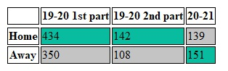

It seems like 2nd part of the last season was the logical continuation of the 1st but this year everything has changed. Guests became even better. But let’s look at the xG stats from 2 sources: FPL and Understat.com (I don’t have data from others like OPTA. ‘Threat’ from FPL was counted as an xG substitute). Numbers are average xG \* 100.

H/A difference for xG

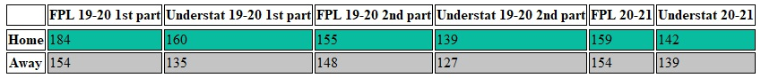

This table shows quite a different picture. Home/Away gap narrowed after lockdown (from 0.3 – 0.25 to 0.03 – 0.12) and remains almost the same this season as in 19-20 post lockdown. Difference in goals scored in the 2nd part of 19-20 and 20-21 could be just random fluctuations. Last season home teams were more lucky and away teams are luckier this season. In general we can conclude that home teams should score about 1/4 - 1/3 goal more with fans and 1/8 goal at best case without.

9 GWs in the post lockdown 19-20 and 10 GWs this season is not a big sample so the strength difference of home and away teams could lead to significant impact on goals and xG numbers. Linear regression which predicts xG based on team strength, Home/Away and opponent average xG conceded can help us. Despite it has the same small sample problem which leads to big variation at least it takes into account who plays against who.

Regression coefficients

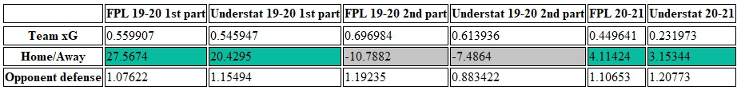

To predict xG you had to add 0.2-0.27 to home team at the beginning of 19-20 for the rest parts the effect is unclear. The gap between 1st part 19-20 and others still holds. H/A made some negative impact on xG of the 2nd part and tiny positive for 20-21 on contrary to goals scored stats. "Team xG" was an average xG for last the 5 GWs. "Opponent defense" was average xG conceded for the whole part considered that's probably the reason why it's coefficient is larger.

There is no direct usage of that data in the FPL game. Probably it just explains how the game changed and became more unpredictable than before. To be of any use I’ll just post top 10 home over away players for 19-20 season and vice versa sorted by home xG - away xG per 90 min (player should have both home and away xG >200 ( or 2) to get to the list).

Top Home

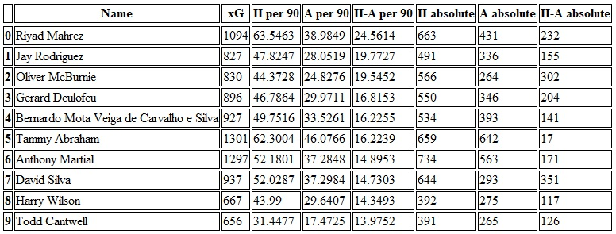

Top Away

